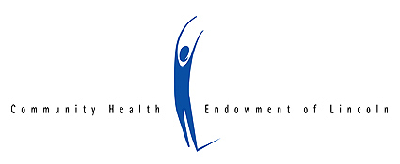
Michael J. Tavlin Leadership Award
2017 Nomination Form

The Community Health Endowment established the Michael J. Tavlin Leadership Award to recognize “exceptional and visionary commitment to board and community service” by an individual board member. Nominations are accepted from non-profit organization staff and board members. CHE will recognize the recipient at our Annual Meeting and give a stipend of $1000 to the agency of their choice to be used for board training and education.

Nominee Information
Name: Click here to enter text.
Address: Click here to enter text.
Phone: Click here to enter text. Email: Click here to enter text.
Agency and Board Position: Click here to enter text.

Nomination Information
In what past or present leadership capacities has the nominee served your organization?
Click here to enter text.

Describe how this nominee demonstrated exceptional and visionary commitment to board and community service in one more of the areas listed in the award description. (Please limit your answer to 300 words or less. The text box will expand to fit your answer.)
Click here to enter text.

Describe how your organization would use a $1,000 stipend to strengthen the capacity of your board. (Please limit your answer to 300 words or less. The text box will expand to fit your answer.)
Click here to enter text.

Nominator Information
Name: Click here to enter text.
Organization/Agency: Click here to enter text.
Position with Organization: Click here to enter text.
Address: Click here to enter text.
Phone: Click here to enter text. Email: Click here to enter text.

After you have completed the form, save it as a Word document with the last name of your nominee in the file name. Send your completed nomination by email to marcia.white@chelincoln.org. Nominations must be received by 5 p.m., Wednesday, March 1, 2017. Questions? Use the email address above or call (402) 436-5516.

