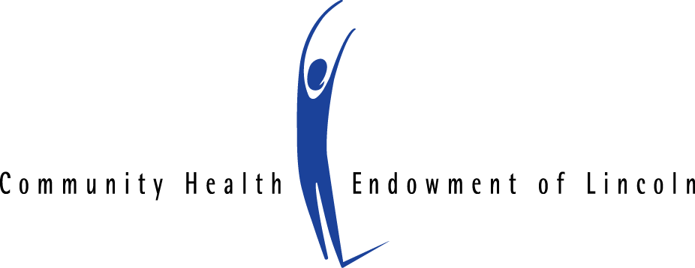

FOR IMMEDIATE RELEASE Contact:
January 25, 2018 Marcia White, Program Manager
402-436-5516, marcia.white@chelincoln.org

‘Caring for an Aging Loved One’ Kicks off Community Conversation Series

The Community Health Endowment of Lincoln (CHE) is sponsoring its fifth series of Community Conversations beginning in February with ‘Caring for an Aging Loved One.’ Other topics in the series include postpartum depression, the life-saving ‘Stop the Bleed’ program, and intergenerational poverty.

Caring for an Aging Loved One, Wednesday, February 7, 2 p.m.

According to the Pew Research Center, nearly a quarter of adults ages 45 to 64 cares for an aging adult. Many are also raising children. This ‘sandwich generation’ of caregivers rises to meet countless challenges. As a loved one's needs increase, caregivers can find themselves overextended physically, mentally, and even financially. Learn more about caring for an aging loved one and the support resources that are available during this Community Conversation.

Presented in partnership with Tabitha Health Care Services and Aging Partners.

Panelists will include:
- Christie Hinrichs, President and CEO of Tabitha, Inc. (Moderator)
- Joyce Kubicek, Aging Program Coordinator, Aging Partners
- Claudia Messineo, a daughter/caregiver who is navigating the elder care system
- Pat Borer, a son/caregiver who is navigating the elder care system

Dates and times for the other events in this Community Conversation series are:
- Beyond Baby Blues: Postpartum Depression, Thursday, March 1, 9:30 a.m.
- Stop the Bleed, Thursday, April 5, 2 p.m.
- Intergenerational Poverty, Wednesday, May 9, 2 p.m.

More information about these events will be available as the dates approach.

All events are free, open to the public and held at CHE, 250 North 21st, Suite 2 (upstairs) in Lincoln. Free parking is available along the west side of 21st Street between O and P Streets and in the lot north of 21st & Q. Registration is requested and available online here: http://che-lincoln.eventbrite.com.

# # #
The Community Health Endowment of Lincoln (CHE) is dedicated to making Lincoln the healthiest community in the nation. To achieve this vision, CHE invests in health-related projects and programs and convenes the community around important health issues. Since its inception in 1998, CHE has returned more than $28 million to the community.

